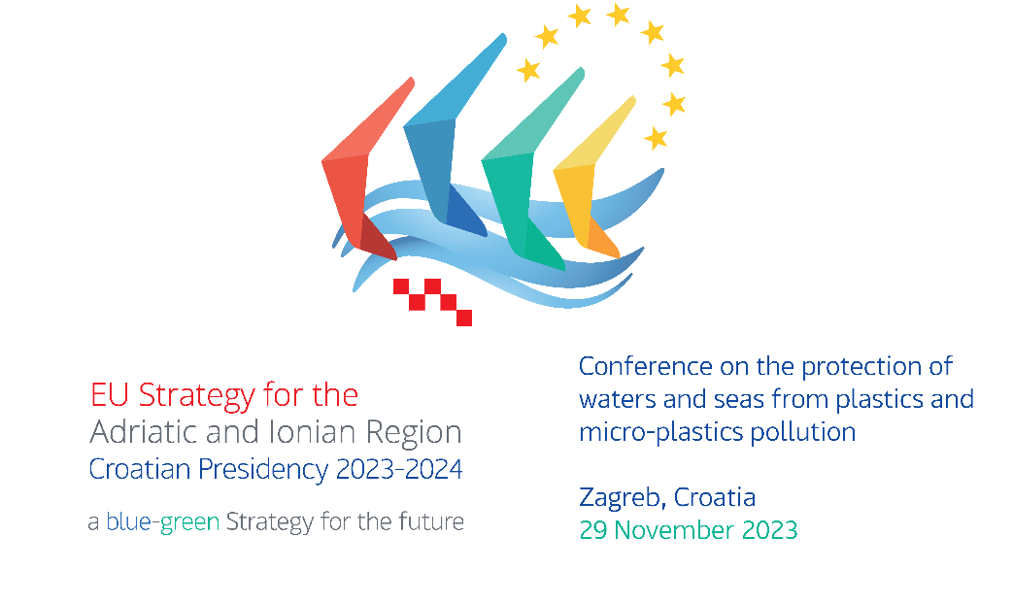
CONFERENCE ON THE PROTECTION OF WATERS AND SEAS FROM PLASTICS AND MICRO-PLASTIC POLLUTION
29th November 2023, Zagreb, Croatia
Venue: Hotel Sheraton, Ul. kneza Borne 2, 10000, Zagreb

Agenda

8:30 – 9:00 | Registration and welcome coffee
9:00 – 9:15 | Opening remarks
- Stella Arneri, Director-General of Directorate for European Territorial Cooperation, Ministry of Regional Development and EU Funds
- Andrea Čović Vidović, Acting Head of Representation of the European Commission in Croatia
- Igor Kreitmeyer, Director-General of Directorate for Nature Protection Ministry of Economy and Sustainable Development
9:15 – 10:30 | Marine Environment and marine litter - Policy framework
- Global initiatives on reduction of plastic and microplastic pollution including marine litter in sea and terrestrial waters
Anamarija Matak, Director-General of Directorate for EIA and sustainable waste management, Ministry of Economy and Sustainable Development (HR)
- Croatian legislative framework and actions in progress
Elizabeta Kos, director of Directorate for Water Management and Sea Protection, Ministry of Economy and Sustainable Development (HR)
- Integrated management and prevention of marine waste in Montenegro and the Western Balkans
Ružica Brnović, Independent Advisor in Directorate for Ecology, in the Ministry of Tourism, Ecology, Sustainable Development and Development of the North, Montenegro
- The Italian policies for the protection of marine environment
Simona Rossi, General Directorate for Natural Heritage and Sea, Italy
- EU Regional Strategies and funding opportunities
Ivana Živković, Senior Expert Advisor. Ministry of Regional Development and EU Funds
10:30 – 10:45 | Coffee Break
10:45 – 12:15 | What is it about – problem analysis from different sectors
- From source to sea — The untold story of marine litter
Mustafa Aydin, PhD, Zero Pollution Expert, European Environment Agency
- Biodiversity adversely impacted by marine plastic debris
Aljoša Duplić, PhD, Director Institute for Environment and Nature, Ministry of Economy and Sustainable Development (HR)
- Microplastics in the aquatic environment from the perspective of water quality monitoring
Mario Šiljeg, PhD, Director of Water Institute Josip Juraj Strossmayer, Croatia
- Effects of tourism on alluvial and marine environments: good, bad, evil or responsible, sustainable and transformative
Izidora Marković Vukadin, PhD, Institute for Tourism, Croatia
- Microplastic load in the Adriatic sea
Mirta Smodlaka Tanković, PhD, Ruder Boskovic Institute, Center for Marine Research, Croatia
- H2020 IMPTOX: Health effects of micro- and nanoplastics- a human biomonitoring study
Ivana Banić, PhD, MSc in Mol Biol, Srebrnjak Children`s Hospital, Zagreb, Croatia
12:15 – 13:00 | Panel discussion – major gaps and future steps
- Aljoša Duplić, PhD, Director, Institute for Environment and Nature, Croatia
- Draženka Stipaničev, PhD, Water Institute Josip Juraj Strossmayer, Croatia
- Ante Mišura, Director of Directorate for Fisheries, Ministry of Agriculture, Croatia
- Mustafa Aydin, PhD, Zero Pollution Expert, European Environment Agency
13:10 | Family photo
13:10 – 14:00 | Lunch break
14:00 – 16:00 | Solutions and good practices
- LIFE Muscles, a circular innovation project to enhance the sustainability of mussel farming
Loris Pietrelli, Legambiente Scientific Committee
- LIFE BLUE LAKES reducing microplastics occurrence in lakes through a multi-integrated approach
Fabrizio Soddu, PM Legambiente project officer
- Horizon SEarch, identificAtion and Collection of marine Litter with Autonomous Robots
Iva Pozniak, DUNEA Regional Development Agency Dubrovnik-Neretva County
- The potential of trawling and diving clubs in reducing the amount of marine litter, current situation and perspective in Croatia
Pero Tutman, PhD, Institute of Oceanography and Fisheries
- LIFE-DREAM Deep REef restoration And litter removal in the Mediterranean sea
Dr. Federica Foglini CNR ISMAR, Project coordinator and the LIFE DREAM consortium
- Circular Second LIFE Water Flow
Dajana Jeglič, dipl. ekon. (UN), Project manager, Clera.One, Slovenia
- Raising awareness on plastic pollution by involvement of young generation
Dragan Zeljko, executive secretary of International Sava River Basin Commission- ISRBC
- Prevention, protection and conservation of the marine environment in view of the pressures and impacts of damaging human activities
Nataša Ugrin, senior advisor, Public Institution RERA SD for coordination and development of Split Dalmatia County
- Plastic Pirates: citizen science to assess amount of litter in fresh water environment
Uroš Robič, Institute for Water od the Republic of Slovenia
16:00 – 17:00 | Project Fair and Networking
- LIFE MUSCLES: Life MUssel Sustainable production (re)cyCLES
- LIFE BLUE LAKES reducing microplastics occurrence in lakes through a multi-integrated approach
- Horizon SEarch, identificAtion and Collection of Marine Litter with Autonomous Robots
- LIFE Deep REef restoration and litter removal in the Mediterranean sea
Smart technology for MArinE Litter SusTainable RemOval and Management
- Horizon 2020 "An innovative analytical platform to investigate the effect and toxicity of micro and nano plastics combined with environmental contaminants on the risk of allergic disease in preclinical and clinical"
- Program LIFE – over 30 years financing green ideas
- INTERREG IT-HR MARLESS “MARine Litter cross-border awarenESS and innovation actions”
- IPA Adriatic Cross-border Cooperation Programme, DeFishGear – DErelict FISHing GEAR Management System in the Adriatic Region
- INTERREG IT-HR ML-REPAIR - REducing and Preventing, an integrated Approach to Marine Litter Management in the Adriatic Sea
- ČistiMO! – baza za unos podataka o prikupljenom morskom otpadu

